Surrey Hills Historical Society Monthly Meeting
Maitland Room, The Cottage, 1 Bedford Avenue, Surrey Hills
Tuesday 21 August 2018 at 8pm
James Nicolas – The writing of a history
‘The Mystery of Fairyland, Kew’
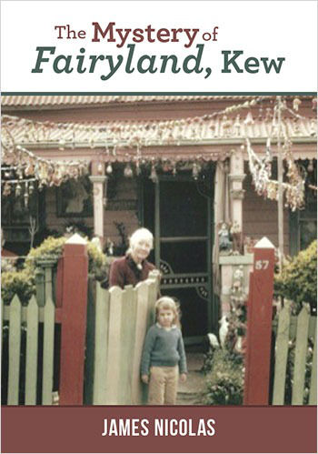
For over 20 years Grace and Jim Tabulo welcomed children from all over Melbourne to their home in Kew – more particularly to its garden. With exhibits, stories, concerts and celebrations, Fairyland was featured in newspapers and magazines in Melbourne and overseas. Grace died in 1965 and in more recent years the property has become the subject of controversy regarding its heritage value. Whatever the outcome of this debate, in his latest book James has explored some of the history of this couple and their motivations and dedication to community.

Visitors very welcome. Supper follows the presentation. $4.50 goes to the Neighbourhood Centre

